Задача "Обновление версии ОС на сервере ds-pr-sp-03" (https://jira.tcsbank.ru/browse/ICP-2273).
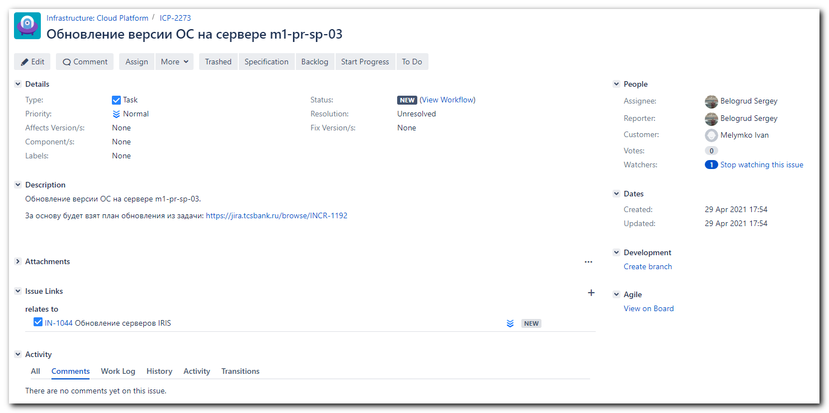

#
# Основная задача.
# "Обновление серверов IRIS" (https://jira.tcsbank.ru/browse/IN-1044)
#
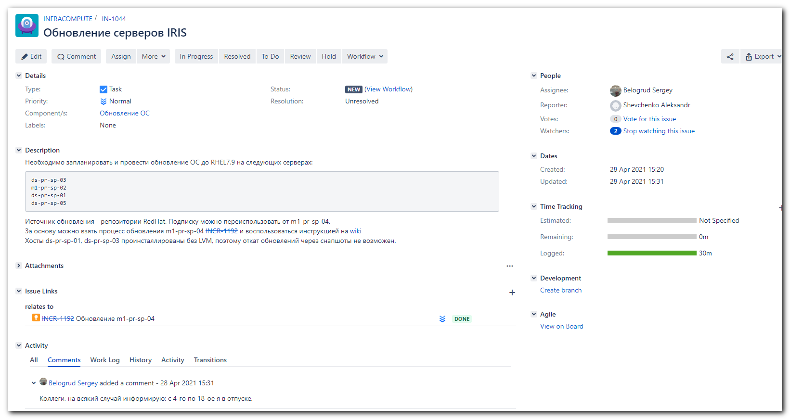

#
# Образцовый план проведения работ.
#
# "Обновление m1-pr-sp-04" (https://jira.tcsbank.ru/browse/INCR-1192)
#
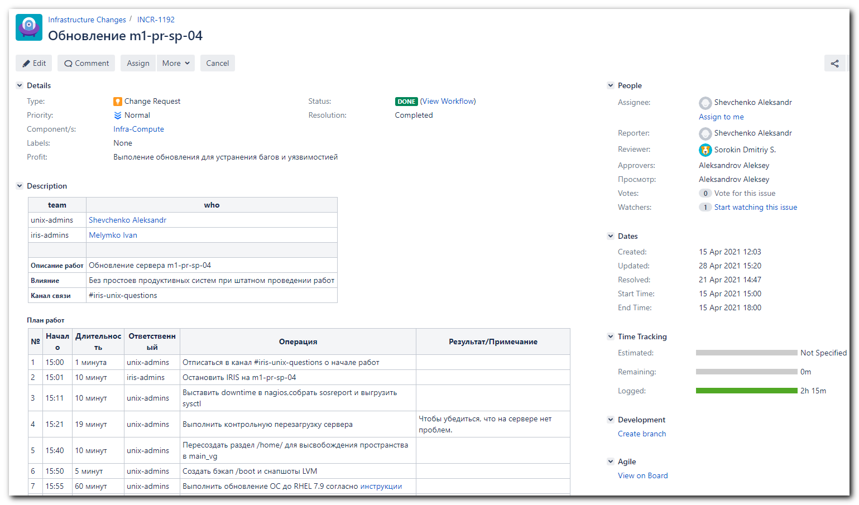

team | who
unix-admins | Shevchenko Aleksandr
iris-admins | Melymko Ivan
Описание работ | Обновление сервера m1-pr-sp-04
Влияние | Без простоев продуктивных систем при штатном проведении работ
Канал связи | #iris-unix-questions

План работ
№ | Начало | Длительность | Ответственный | Операция | Результат/Примечание
1 | 15:00 | 1 минута | unix-admins | Отписаться в канал #iris-unix-questions о начале работ
2 | 15:01 | 10 минут | iris-admins | Остановить IRIS на m1-pr-sp-04
3 | 15:11 | 10 минут | unix-admins | Выставить downtime в nagios,собрать sosreport и выгрузить sysctl
4 | 15:21 | 19 минут | unix-admins | Выполнить контрольную перезагрузку сервера | Чтобы убедиться, что на сервере нет проблем.
5 | 15:40 | 10 минут | unix-admins | Пересоздать раздел /home/ для высвобождения пространства в main_vg
6 | 15:50 | 5 минут | unix-admins | Создать бэкап /boot и снапшоты LVM
7 | 15:55 | 60 минут | unix-admins | Выполнить обновление ОС до RHEL 7.9 согласно инструкции
8 | 16:55 | 10 минут | unix-admins | Проверить состояние systemd unitов, исправить failed
9 | 17:05 | 10 минут | unix-admins | Проверить статус сервера в nagios, устранить замечания
10 | 17:15 | 1 минута | unix-admins | Выгрузить sysctl
11 | 17:16 | 1 минута | unix-admins | Снять downtime в nagios
12 | 17:17 | 10 минут | iris-admins | Запустить IRIS на m1-pr-sp-04
13 | 17:27 | 1 минута | unix-admins | Удалить снапшоты LVM | после получения ОK от iris-admins
14 | 17:28 | 1 минута | unix-admins | Отписаться в канал #iris-unix-questions об окончании работ
В случае возникновения проблем, которые не позволяют выполнить работы, перейти к плану отката

План отката
№ | Длительность | Ответственный | Операция | Результат/Примечание
1 | 20 минут | unix-admins | Откатить снапшоты LVM и перезагрузить сервер m1-pr-sp-04
2 | 10 минут | unix-admins | Проверить логи ОС на наличие ошибок
3 | 1 минута | unix-admins | Отписаться в канал #iris-unix-questions о выполненном откате

# Was made downtime in nagios for server ds-pr-sp-03.

# There is no found channel #iris-unix-questions in Slack.

[root@ds-pr-sp-03 ~]# cat /etc/redhat-release
Red Hat Enterprise Linux Server release 7.5 (Maipo)
[root@ds-pr-sp-03 ~]# subscription-manager status
+-------------------------------------------+
System Status Details
+-------------------------------------------+
Overall Status: Unknown

[root@ds-pr-sp-03 ~]#

[root@ds-pr-sp-03 ~]# subscription-manager list
+-------------------------------------------+
Installed Product Status
+-------------------------------------------+
Product Name: Red Hat Enterprise Linux Server
Product ID: 69
Version: 7.5
Arch: x86_64
Status: Unknown
Status Details:
Starts:
Ends:

[root@ds-pr-sp-03 ~]#

[root@ds-pr-sp-03 ~]# egrep -e "^proxy_hostname|^proxy_port|^proxy_user|^proxy_password" /etc/rhsm/rhsm.conf
proxy_hostname =
proxy_port =
proxy_user =
proxy_password =
[root@ds-pr-sp-03 ~]# vim /etc/rhsm/rhsm.conf
[root@ds-pr-sp-03 ~]#
[root@ds-pr-sp-03 ~]# egrep -e "^proxy_hostname|^proxy_port|^proxy_user|^proxy_password" /etc/rhsm/rhsm.conf
proxy_hostname = proxy.tcsbank.ru
proxy_port = 8080
proxy_user = rhsm_user
proxy_password =6eKoEvNHFS5IycxhqH5W
[root@ds-pr-sp-03 ~]#

[root@ds-pr-sp-03 ~]# read -s -p "Enter RHN Password: " RHN_PASSWORD ; subscription-manager register --username=tcsbank17012012 --password=$RHN_PASSWORD --auto-attach
Enter RHN Password: Registering to: subscription.rhsm.redhat.com:443/subscription
The system has been registered with ID: 494e0cc4-008c-4ff2-950f-4e17d9001b50
The registered system name is: ds-pr-sp-03.tcsbank.ru
Installed Product Current Status:
Product Name: Red Hat Enterprise Linux Server
Status: Not Subscribed

Unable to find available subscriptions for all your installed products.
[root@ds-pr-sp-03 ~]#

#
# Here I look at other server - how it is about subscription on it.
# And I removed subscription from it.
#
[s.belogrud@nb2339]# ssh bsv@m1-pr-sp-04
[bsv@m1-pr-sp-04 ~]$ sudo -i
[sudo] password for bsv:
Sorry, try again.
[sudo] password for bsv:
[root@m1-pr-sp-04 ~]#
[root@m1-pr-sp-04 ~]# subscription-manager status
+-------------------------------------------+
System Status Details
+-------------------------------------------+
Overall Status: Insufficient

Red Hat Enterprise Linux Server, Standard (Physical or Virtual Nodes):
- Only supports 2 of 4 sockets.

System Purpose Status: Not Specified

[root@m1-pr-sp-04 ~]# subscription-manager remove --all && subscription-manager unregister
1 local certificate has been deleted.
1 subscription removed at the server.
Unregistering from: subscription.rhsm.redhat.com:443/subscription
System has been unregistered.
[root@m1-pr-sp-04 ~]# subscription-manager status
+-------------------------------------------+
System Status Details
+-------------------------------------------+
Overall Status: Unknown

System Purpose Status: Unknown

[root@m1-pr-sp-04 ~]#

#
# Here I still cannot make subscription via command line.
#
[root@ds-pr-sp-03 ~]# read -s -p "Enter RHN Password: " RHN_PASSWORD ; subscription-manager register --username=tcsbank17012012 --password=$RHN_PASSWORD --auto-attach
Enter RHN Password: This system is already registered. Use --force to override
[root@ds-pr-sp-03 ~]# read -s -p "Enter RHN Password: " RHN_PASSWORD ; subscription-manager register --username=tcsbank17012012 --password=$RHN_PASSWORD --auto-attach --force
Enter RHN Password: Unregistering from: subscription.rhsm.redhat.com:443/subscription
The system with UUID 494e0cc4-008c-4ff2-950f-4e17d9001b50 has been unregistered
All local data removed
Registering to: subscription.rhsm.redhat.com:443/subscription
The system has been registered with ID: 179556b0-fb32-487b-965c-bd3032104d12
The registered system name is: ds-pr-sp-03.tcsbank.ru
Installed Product Current Status:
Product Name: Red Hat Enterprise Linux Server
Status: Not Subscribed

Unable to find available subscriptions for all your installed products.
[root@ds-pr-sp-03 ~]#

[root@ds-pr-sp-03 ~]# subscription-manager status
+-------------------------------------------+
System Status Details
+-------------------------------------------+
Overall Status: Invalid

Red Hat Enterprise Linux Server:
- Not supported by a valid subscription.

[root@ds-pr-sp-03 ~]# subscription-manager status
+-------------------------------------------+
System Status Details
+-------------------------------------------+
Overall Status: Insufficient

Red Hat Enterprise Linux Server, Standard (Physical or Virtual Nodes):
- Only supports 2 of 4 sockets.

[root@ds-pr-sp-03 ~]# subscription-manager release --list
No release versions available, please check subscriptions.
[root@ds-pr-sp-03 ~]#

#
# I went to follow web-page:
# https://access.redhat.com/management/systems
# Remove subscriptions from several servers manually.
# After follow command the server appears in search field.
#
[root@ds-pr-sp-03 ~]# read -s -p "Enter RHN Password: " RHN_PASSWORD ; subscription-manager register --username=tcsbank17012012 --password=$RHN_PASSWORD --auto-attach --force
Enter RHN Password: Unregistering from: subscription.rhsm.redhat.com:443/subscription
The system with UUID 494e0cc4-008c-4ff2-950f-4e17d9001b50 has been unregistered
All local data removed
Registering to: subscription.rhsm.redhat.com:443/subscription
The system has been registered with ID: 179556b0-fb32-487b-965c-bd3032104d12
The registered system name is: ds-pr-sp-03.tcsbank.ru
Installed Product Current Status:
Product Name: Red Hat Enterprise Linux Server
Status: Not Subscribed

Unable to find available subscriptions for all your installed products.
[root@ds-pr-sp-03 ~]#
#
# Then I went dipper into this server into "Subscription" and assing one available subscription manually.
#
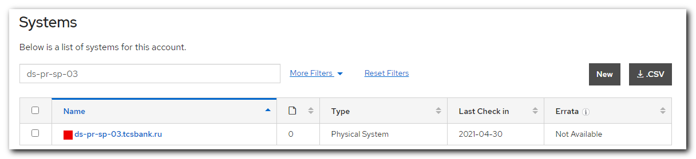
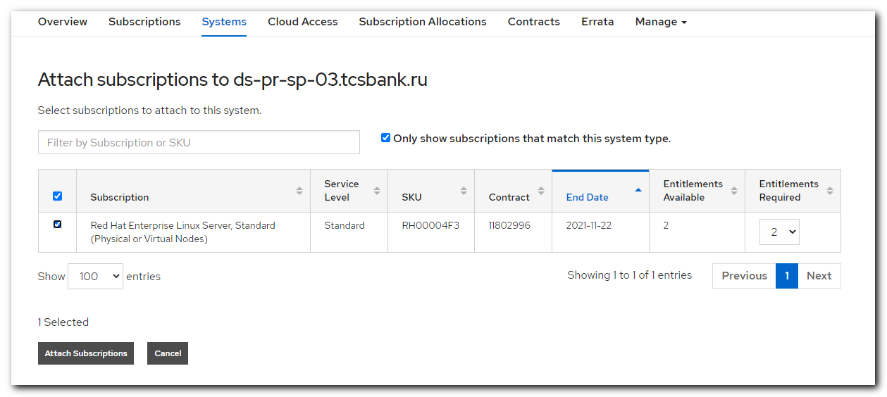
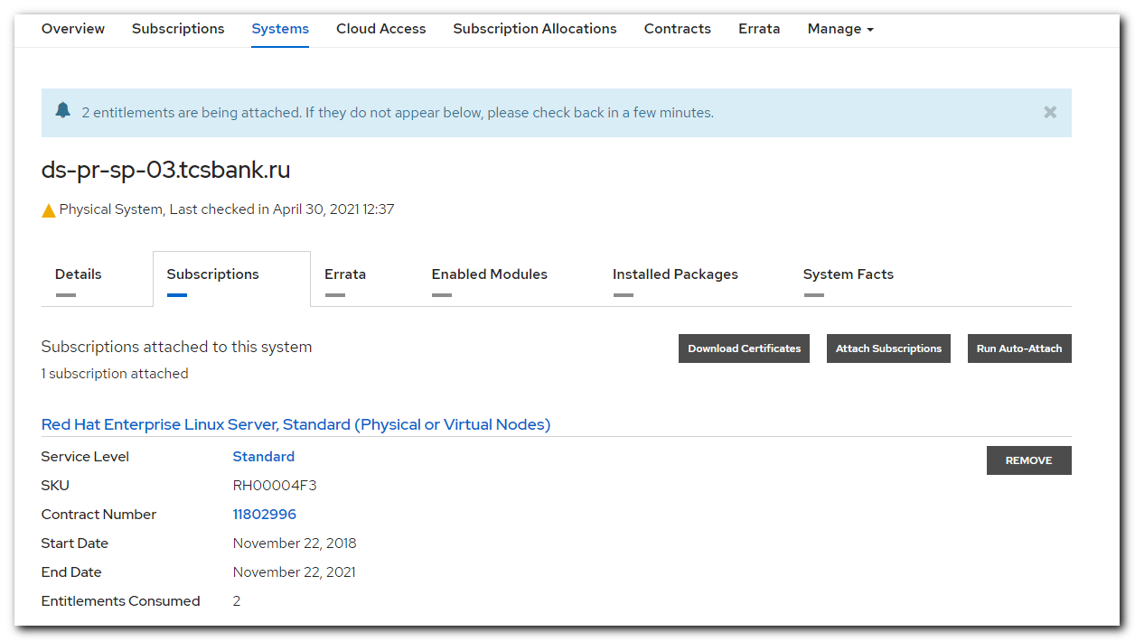
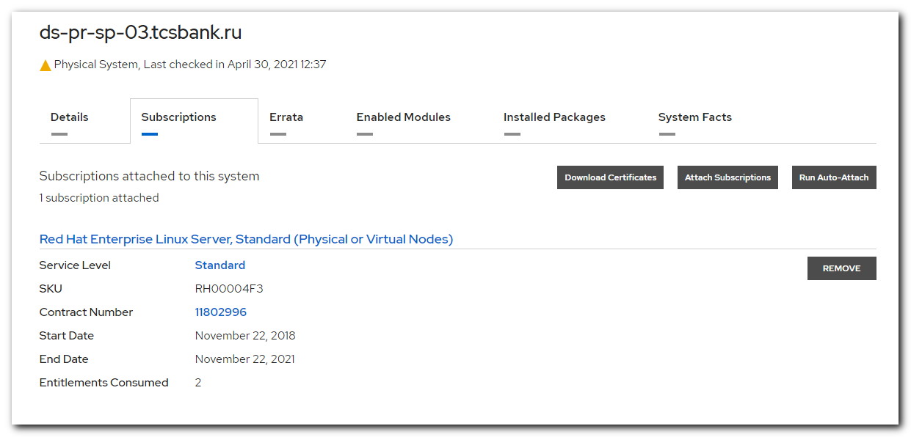

#
# Here I just try any option of this utility.
#
[root@ds-pr-sp-03 ~]# subscription-manager identity
system identity: f9a810e3-215d-4a50-bbbb-9bfce68be461
name: ds-pr-sp-03.tcsbank.ru
org name: 6534084
org ID: 6534084
[root@ds-pr-sp-03 ~]#

#
# This command require to receive all appropriate info about subscription.
# As I undestand after that was created /etc/yum.repos.d/redhat.repo file.
#
[root@ds-pr-sp-03 ~]# subscription-manager refresh
All local data refreshed
[root@ds-pr-sp-03 ~]#

[root@ds-pr-sp-03 ~]# subscription-manager status
+-------------------------------------------+
System Status Details
+-------------------------------------------+
Overall Status: Insufficient

Red Hat Enterprise Linux Server, Standard (Physical or Virtual Nodes):
- Only supports 2 of 4 sockets.

[root@ds-pr-sp-03 ~]# subscription-manager release --list
+-------------------------------------------+
Available Releases
+-------------------------------------------+
7.0
7.1
7.2
7.3
7.4
7.5
7.6
7.7
7.8
7.9
7Server
[root@ds-pr-sp-03 ~]#

[root@ds-pr-sp-03 ~]# ls -Alh /etc/yum.repos.d/
total 132K
-rw-r--r-- 1 root root 109K Apr 30 12:55 redhat.repo
-rw-r--r-- 1 root root 145 Oct 30 2019 tcs-centos.repo
-rw-r--r-- 1 root root 150 Oct 30 2019 tcs-epel.repo
-rw-r--r-- 1 root root 135 Sep 8 2020 tcs-influx.repo
-rw-r--r-- 1 root root 165 Oct 30 2019 tcs-ius.repo
-rw-r--r-- 1 root root 185 Oct 30 2019 tcs-rhel-server-rpms.repo
[root@ds-pr-sp-03 ~]# ls -Alh ~/work/20210430-1132/backup/
total 24K
-rw-r--r-- 1 root root 358 Apr 30 11:33 redhat.repo
-rw-r--r-- 1 root root 145 Apr 30 11:33 tcs-centos.repo
-rw-r--r-- 1 root root 150 Apr 30 11:33 tcs-epel.repo
-rw-r--r-- 1 root root 135 Apr 30 11:33 tcs-influx.repo
-rw-r--r-- 1 root root 165 Apr 30 11:33 tcs-ius.repo
-rw-r--r-- 1 root root 185 Apr 30 11:33 tcs-rhel-server-rpms.repo
[root@ds-pr-sp-03 ~]# rm /etc/yum.repos.d/tcs-*
rm: remove regular file ‘/etc/yum.repos.d/tcs-centos.repo’? y
rm: remove regular file ‘/etc/yum.repos.d/tcs-epel.repo’? y
rm: remove regular file ‘/etc/yum.repos.d/tcs-influx.repo’? y
rm: remove regular file ‘/etc/yum.repos.d/tcs-ius.repo’? y
rm: remove regular file ‘/etc/yum.repos.d/tcs-rhel-server-rpms.repo’? y
[root@ds-pr-sp-03 ~]# yum repolist
Loaded plugins: langpacks, product-id, search-disabled-repos, subscription-manager
rhel-7-server-rpms | 3.5 kB 00:00:00
(1/3): rhel-7-server-rpms/7Server/x86_64/updateinfo | 4.0 MB 00:00:00
(2/3): rhel-7-server-rpms/7Server/x86_64/group | 631 kB 00:00:00
(3/3): rhel-7-server-rpms/7Server/x86_64/primary_db | 81 MB 00:00:02
repo id repo name status
rhel-7-server-rpms/7Server/x86_64 Red Hat Enterprise Linux 7 Server (RPMs) 31,758
repolist: 31,758
[root@ds-pr-sp-03 ~]#

[root@ds-pr-sp-03 ~]# subscription-manager release --set 7.9
Release set to: 7.9
[root@ds-pr-sp-03 ~]#

[root@ds-pr-sp-03 ~]# yum clean all
Loaded plugins: langpacks, product-id, search-disabled-repos, subscription-manager
Cleaning repos: rhel-7-server-rpms
Cleaning up everything
Maybe you want: rm -rf /var/cache/yum, to also free up space taken by orphaned data from disabled or removed repos
[root@ds-pr-sp-03 ~]# rm -rf /var/cache/yum
[root@ds-pr-sp-03 ~]#

[root@ds-pr-sp-03 ~]# yum repolist
Loaded plugins: langpacks, product-id, search-disabled-repos, subscription-manager
rhel-7-server-rpms | 3.5 kB 00:00:00
(1/3): rhel-7-server-rpms/x86_64/group | 631 kB 00:00:00
(2/3): rhel-7-server-rpms/x86_64/updateinfo | 4.0 MB 00:00:00
(3/3): rhel-7-server-rpms/x86_64/primary_db | 81 MB 00:00:02
repo id repo name status
rhel-7-server-rpms/x86_64 Red Hat Enterprise Linux 7 Server (RPMs) 31,758
repolist: 31,758
[root@ds-pr-sp-03 ~]#

#
# I only downloaded packages.
# To test internet connection almost.
#
[root@ds-pr-sp-03 ~]# yum update
...
Transaction Summary
=========================================================================================================================================================
Install 2 Packages (+9 Dependent packages)
Upgrade 385 Packages

Total download size: 425 M
Is this ok [y/d/N]: d
...
(395/396): yum-utils-1.1.31-54.el7_8.noarch.rpm | 122 kB 00:00:00
(396/396): zlib-1.2.7-19.el7_9.x86_64.rpm | 90 kB 00:00:00
---------------------------------------------------------------------------------------------------------------------------------------------------------
Total 3.4 MB/s | 425 MB 00:02:03
exiting because "Download Only" specified
[root@ds-pr-sp-03 ~]#

#
# I attempted to make some backup, but there is no access to nfs resource.
#
[root@ds-pr-sp-03 ~]# mkdir -p /mnt/techsupport
[root@ds-pr-sp-03 ~]# mount -t nfs fs-nfsmb3.tcsbank.ru:/db_sosreport /mnt/techsupport -o rw,bg,vers=3,tcp,timeo=600,rsize=65536,wsize=65536,hard
mount.nfs: access denied by server while mounting fs-nfsmb3.tcsbank.ru:/db_sosreport
[root@ds-pr-sp-03 ~]# rmdir /mnt/techsupport
[root@ds-pr-sp-03 ~]#

[root@ds-pr-sp-03 ~]# reboot
Connection to ds-pr-sp-03 closed by remote host.
Connection to ds-pr-sp-03 closed.
[s.belogrud@nb2339]#

#
# Here I set up our root password for any case.
#
[bsv@ds-pr-sp-03 ~]$ su - root
Password:
su: Authentication failure
[bsv@ds-pr-sp-03 ~]$ sudo -i
[root@ds-pr-sp-03 ~]# passwd
Changing password for user root.
New password:
Retype new password:
passwd: all authentication tokens updated successfully.
[root@ds-pr-sp-03 ~]#

#
# Here I ran update process.
#
[root@ds-pr-sp-03 ~]# yum update
...
...
Replaced:
iwl7265-firmware.noarch 0:22.0.7.0-62.el7

Complete!
[root@ds-pr-sp-03 ~]#

[root@ds-pr-sp-03 ~]# reboot
Connection to ds-pr-sp-03 closed by remote host.
Connection to ds-pr-sp-03 closed.
[root@ds-pr-sp-03 ~]#

[s.belogrud@nb2339]# ssh bsv@ds-pr-sp-03
[bsv@ds-pr-sp-03 ~]$ sudo -i
[sudo] password for bsv:
[root@ds-pr-sp-03 ~]#
[root@ds-pr-sp-03 ~]# cat /etc/redhat-release
Red Hat Enterprise Linux Server release 7.9 (Maipo)
[root@ds-pr-sp-03 ~]#

[root@ds-pr-sp-03 ~]# subscription-manager remove --all && subscription-manager unregister
1 local certificate has been deleted.
1 subscription removed at the server.
Unregistering from: subscription.rhsm.redhat.com:443/subscription
System has been unregistered.
[root@ds-pr-sp-03 ~]#

#
# I seen wrong repositories => CentOS.
# I removed all wrong and old repositories.
# I applyed my playbook to create correct list of repositories.
#
[root@ds-pr-sp-03 ~]# rm /etc/yum.repos.d/redhat.repo
rm: remove regular file ‘/etc/yum.repos.d/redhat.repo’? y
[root@ds-pr-sp-03 ~]# cp ~/work/20210430-1132/backup/* /etc/yum.repos.d/
[root@ds-pr-sp-03 ~]# yum repolist
Loaded plugins: langpacks, product-id, search-disabled-repos, subscription-manager

This system is not registered with an entitlement server. You can use subscription-manager to register.

centos | 3.6 kB 00:00:00
epel | 4.7 kB 00:00:00
ius | 2.9 kB 00:00:00
rhel-server-rpms | 3.0 kB 00:00:00
tcs-influxdb | 2.5 kB 00:00:00
(1/8): centos/x86_64/group_gz | 153 kB 00:00:00
(2/8): epel/x86_64/group_gz | 96 kB 00:00:00
(3/8): epel/x86_64/updateinfo | 1.0 MB 00:00:00
(4/8): centos/x86_64/primary_db | 6.1 MB 00:00:00
(5/8): epel/x86_64/primary_db | 6.9 MB 00:00:00
(6/8): tcs-influxdb/primary_db | 53 kB 00:00:00
(7/8): ius/primary_db | 377 kB 00:00:00
(8/8): rhel-server-rpms/7Server/x86_64/primary_db | 76 MB 00:00:00
repo id repo name status
centos/x86_64 CentOS-7Server - Base 10,072
epel/x86_64 Extra Packages for Enterprise Linux 7 13,585
ius IUS Community Packages for Enterprise Linux 7 - x86_64 713
rhel-server-rpms/7Server/x86_64 Red Hat Enterprise Linux 7Server Server (RPMs) 34,755
tcs-influxdb tcs-influxdb 221
repolist: 59,346
[root@ds-pr-sp-03 ~]#

[support@nb2339]# export ANSIBLE_CONFIG=ansible.cfg ; logfile="$(date +%Y%m%d-%H%M).playbook.log.txt" ; ansible-playbook 20210302-1613.repository.yml -i list_of_hosts --become --extra-vars "ansible_user=bsv ansible_password=$(pass common/linux-bsv) ansible_sudo_pass=$(pass common/linux-bsv) ansible_ssh_common_args='-oStrictHostKeyChecking=no -oPubkeyAuthentication=no -oUserKnownHostsFile=/dev/null'" | tee -a ./output/${logfile}

#
# I copyed back two files with configuration to access to "ius" and "influxdb", that were previously backed up.
[root@ds-pr-sp-03 ~]# yum repolist
Loaded plugins: langpacks, product-id, search-disabled-repos, subscription-manager

This system is not registered with an entitlement server. You can use subscription-manager to register.

repo id repo name status
ius IUS Community Packages for Enterprise Linux 7 - x86_64 713
tcs-epel/7Server/x86_64 Extra Packages for Enterprise Linux 7Server - x86_64 13,585
tcs-influxdb tcs-influxdb 221
tcs-rhel-base/7Server/x86_64 Red Hat Enterprise Linux Server Base(v. 6/7 for x86_64) 34,755
tcs-rhel-extras/7Server Red Hat Enterprise Linux Server Extras(v. 6/7 for x86_64) 1,347
tcs-rhel-optional/7Server Red Hat Enterprise Linux Server Optional(v. 6/7 for x86_64) 17,536
repolist: 68,157
[root@ds-pr-sp-03 ~]#

[root@ds-pr-sp-03 ~]# ls -Alh /etc/yum.repos.d/
total 20K
-rw-r--r-- 1 root root 358 Apr 30 16:16 redhat.repo
-rw-r--r-- 1 root root 1.2K Apr 30 16:15 tcs-epel.repo
-rw-r--r-- 1 root root 135 Apr 30 16:17 tcs-influx.repo
-rw-r--r-- 1 root root 165 Apr 30 16:17 tcs-ius.repo
-rw-r--r-- 1 root root 974 Apr 30 16:15 tcs-redhat.repo
[root@ds-pr-sp-03 ~]# cat /etc/yum.repos.d/redhat.repo
#
# Certificate-Based Repositories
# Managed by (rhsm) subscription-manager
#
# *** This file is auto-generated. Changes made here will be over-written. ***
# *** Use "subscription-manager repo-override --help" if you wish to make changes. ***
#
# If this file is empty and this system is subscribed consider
# a "yum repolist" to refresh available repos
#
[root@ds-pr-sp-03 ~]#

